**STARAGILE GIT AND GITHUB ASSIGNMENT 2**

1. **Initialize any folder as Git Repository:**
   * Open a terminal or command prompt.
   * Navigate to the folder you want to initialize as a Git repository.
   * Run the command: **git init**

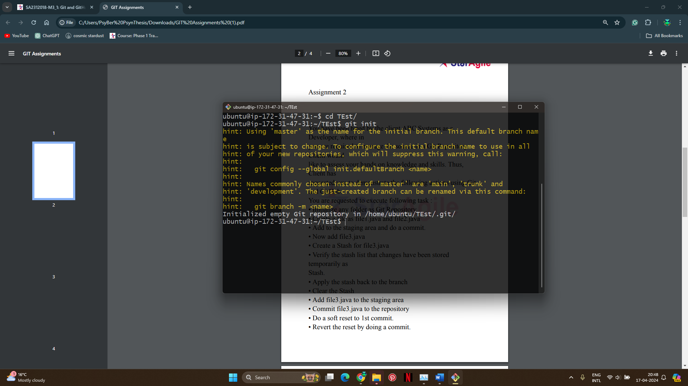

1. **Create file1.java and file2.java:**
   * Create two Java files named file1.java and file2.java in the repository folder.

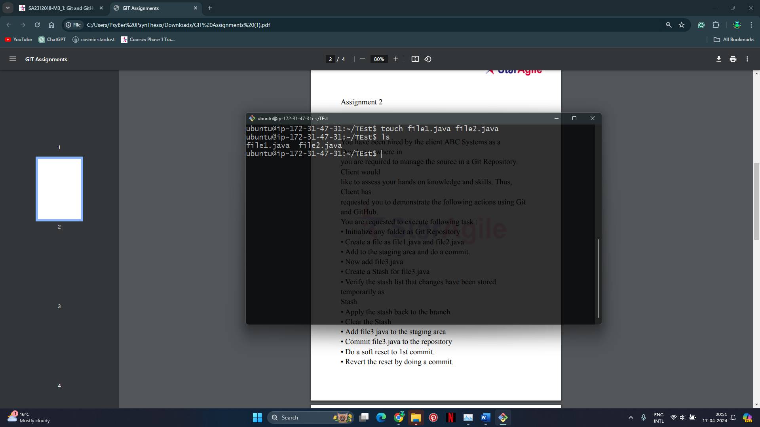

1. **Add to the staging area and do a commit:**
   * Run the commands: git commit -m "Initial commit"

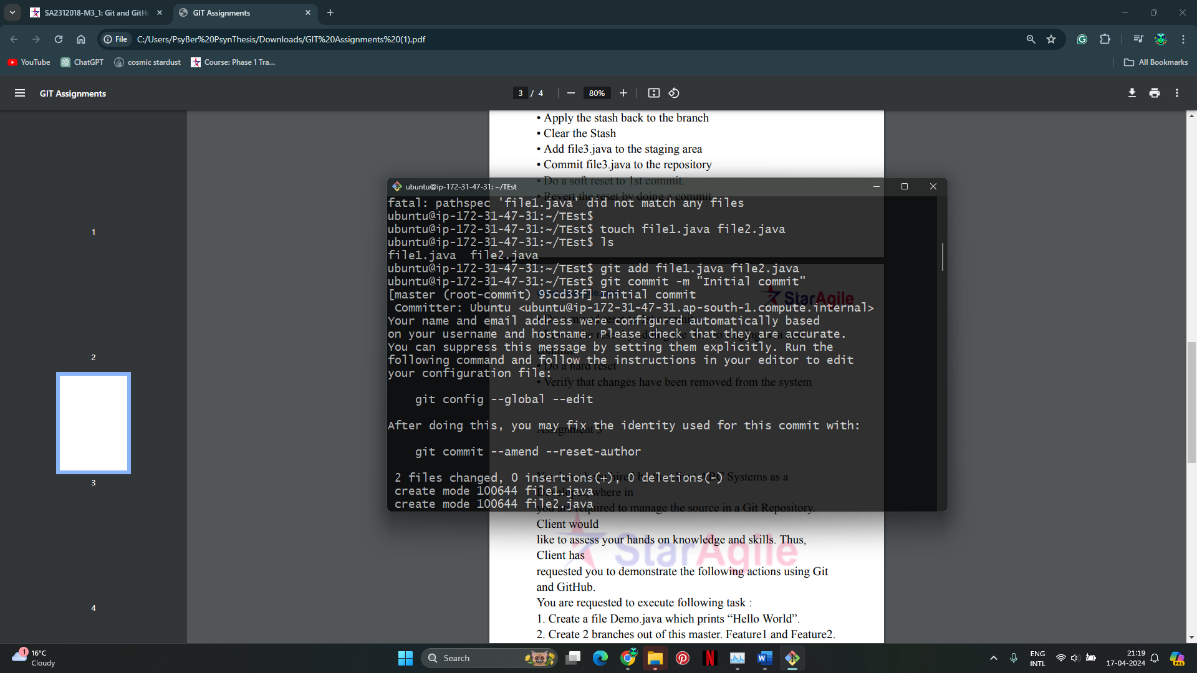

1. **Now add file3.java:**
   * Create a file named file3.java in the repository folder.

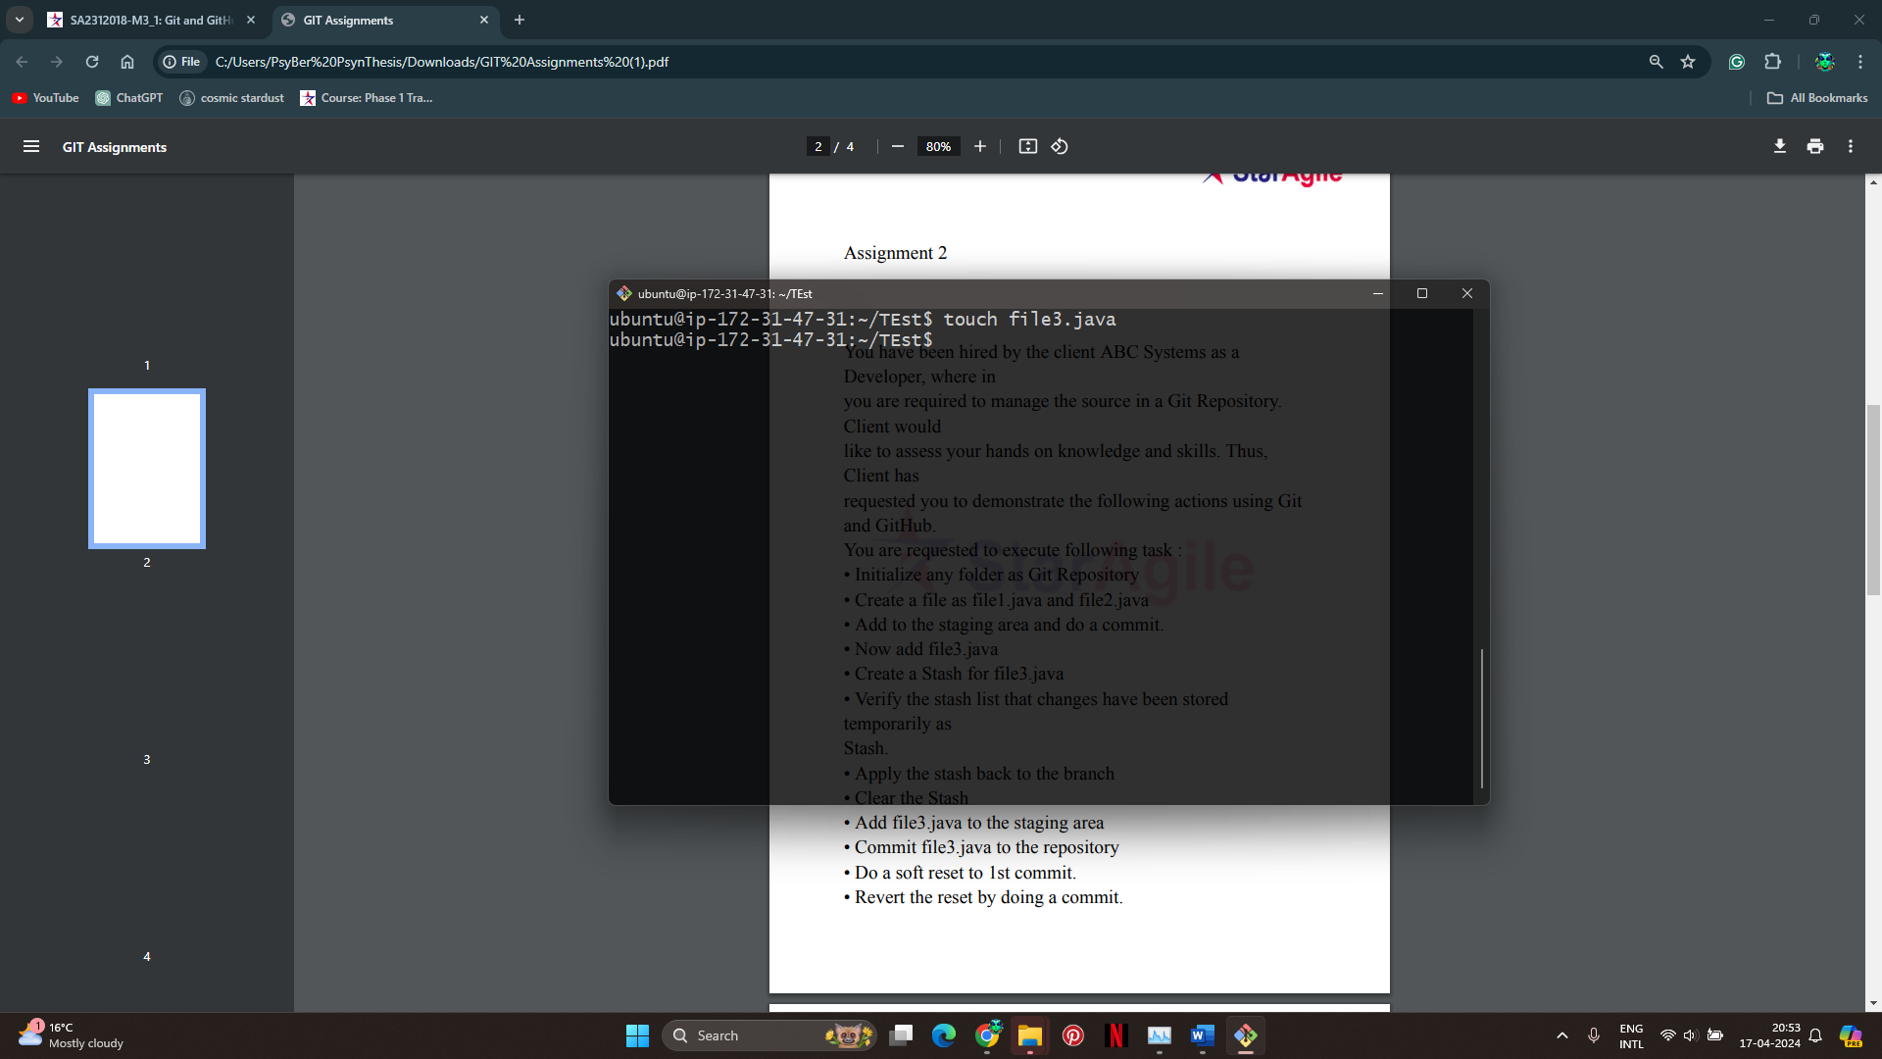

1. **Create a Stash for file3.java:**
   * Run the command: **git stash save "Stashing file3.java"**

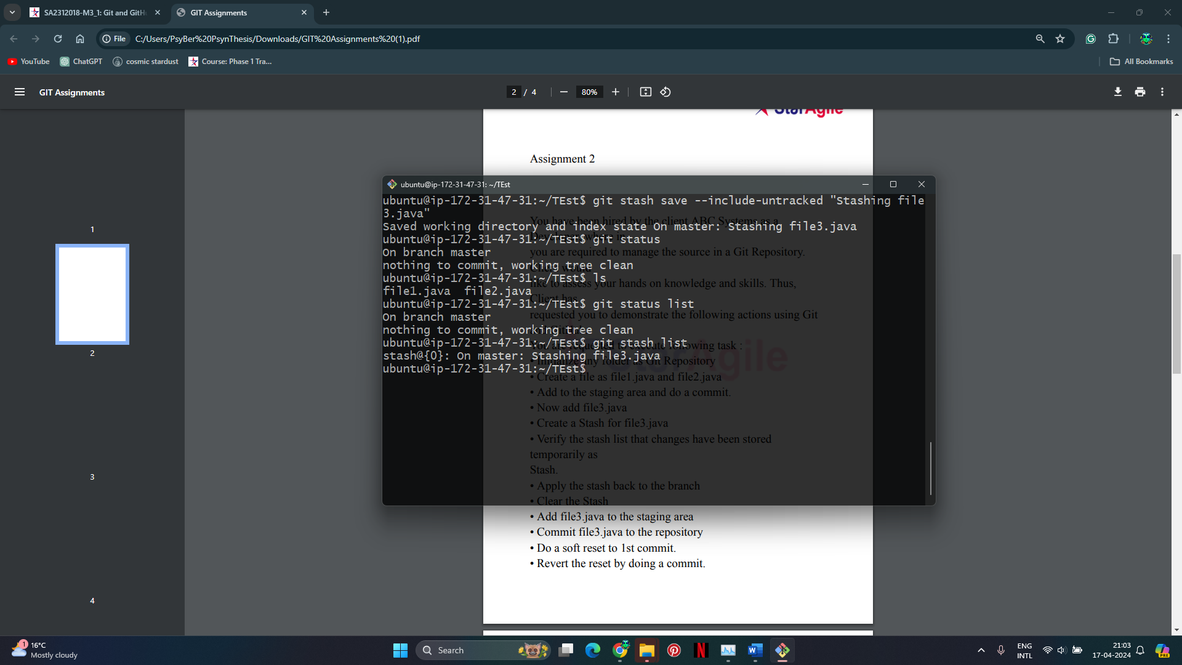

1. **Verify the stash list:**
   * Run the command: **git stash list**



1. **Apply the stash back to the branch:**
   * Run the command: **git stash apply**

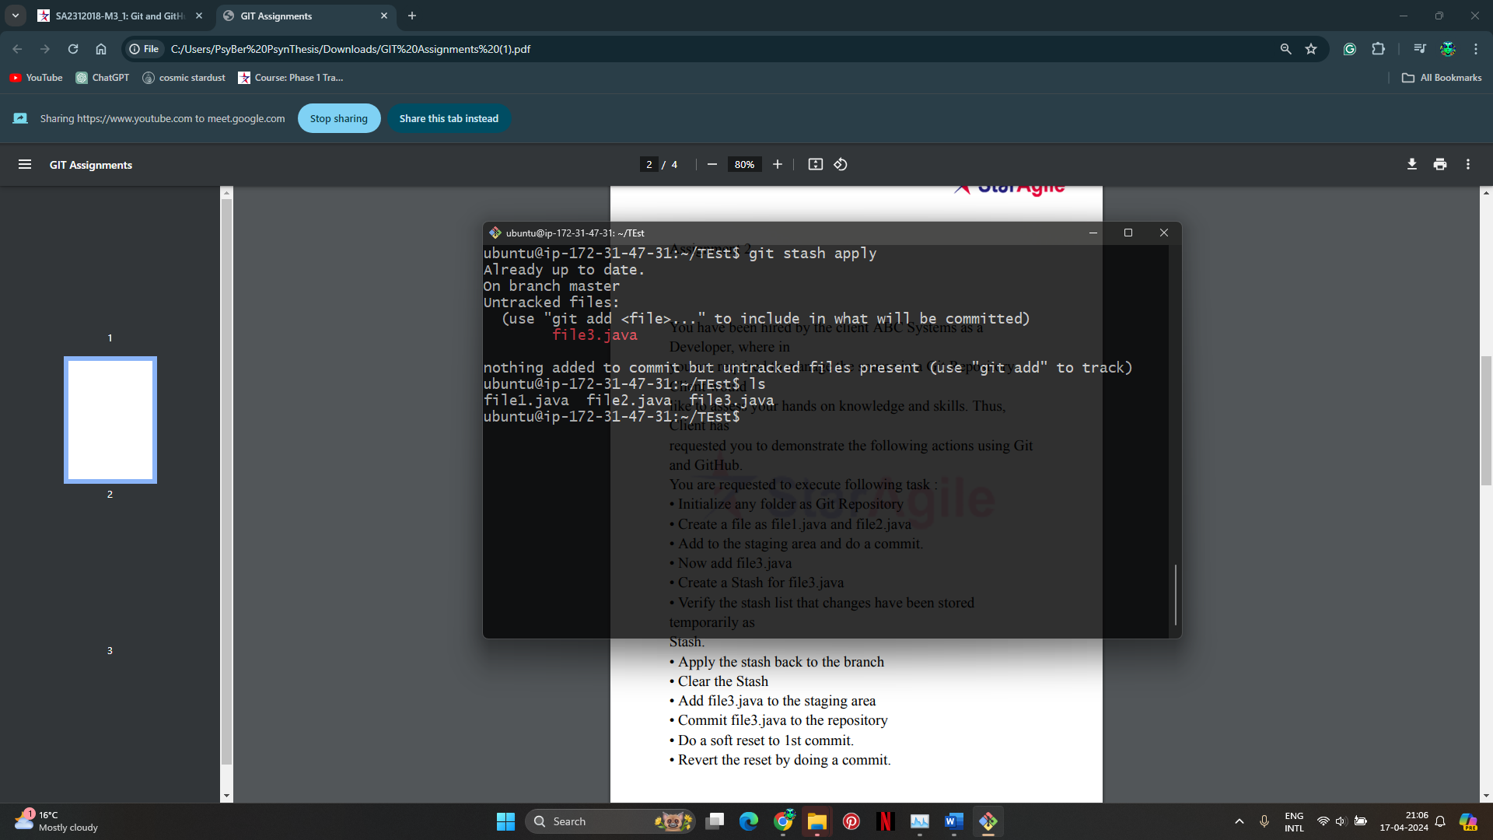

1. **Clear the Stash:**
   * Run the command: **git stash clear**

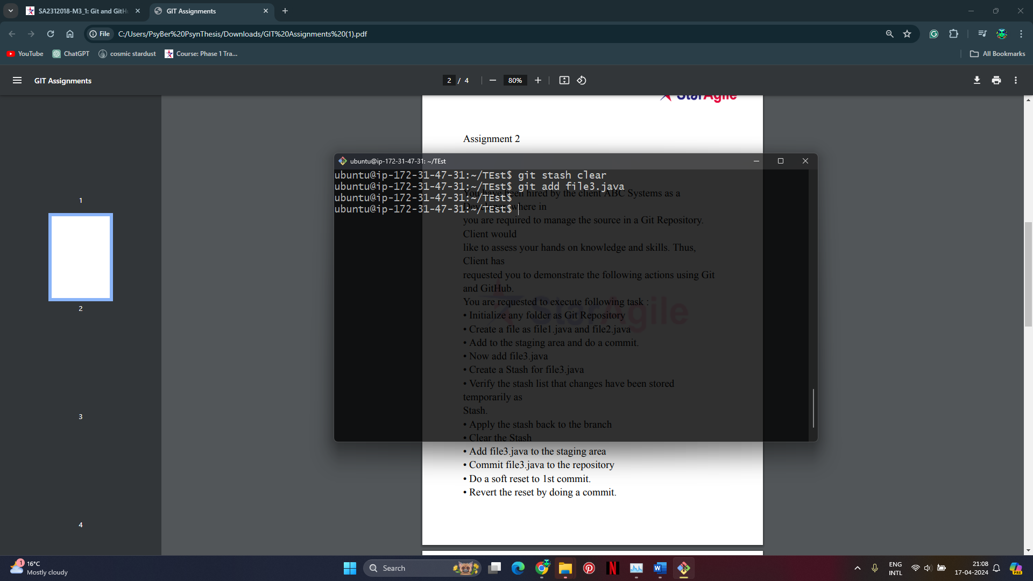

1. **Add file3.java to the staging area:**
   * Run the command: **git add file3.java**



1. **Commit file3.java to the repository:**
   * Run the command: **git commit -m "Add file3.java"**

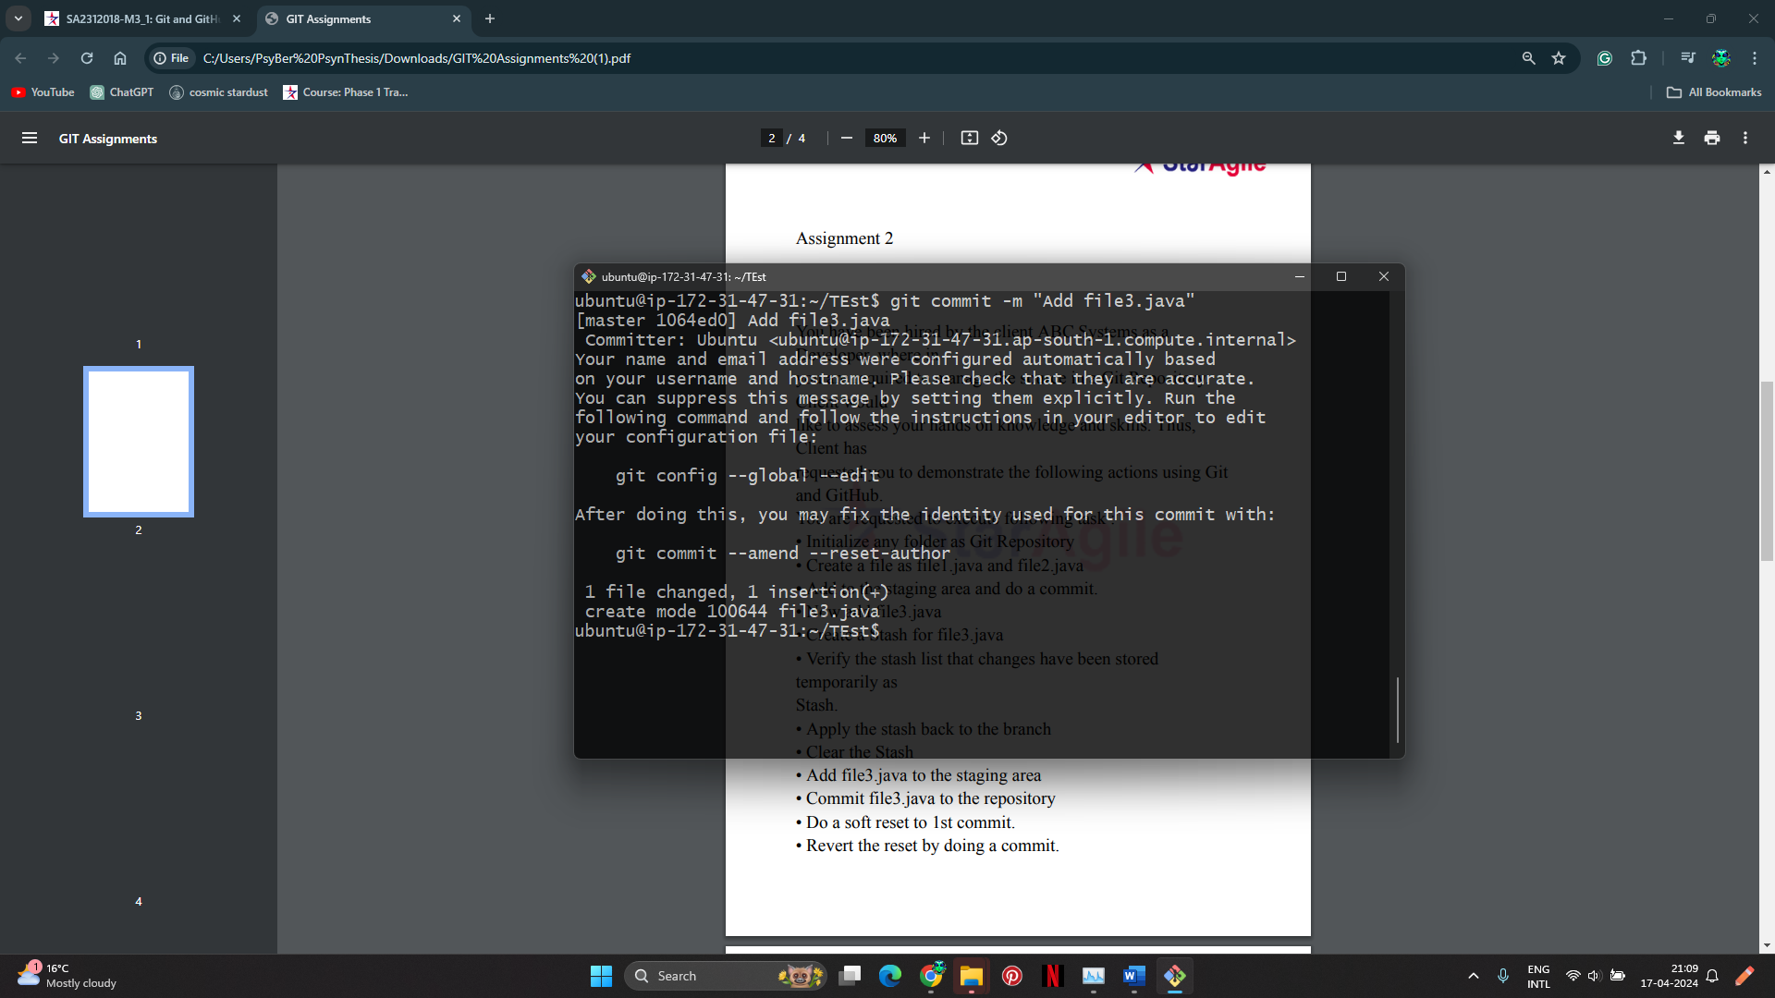

1. **Do a soft reset to 1st commit:**
   * Run the command: **git reset --soft HEAD~1**

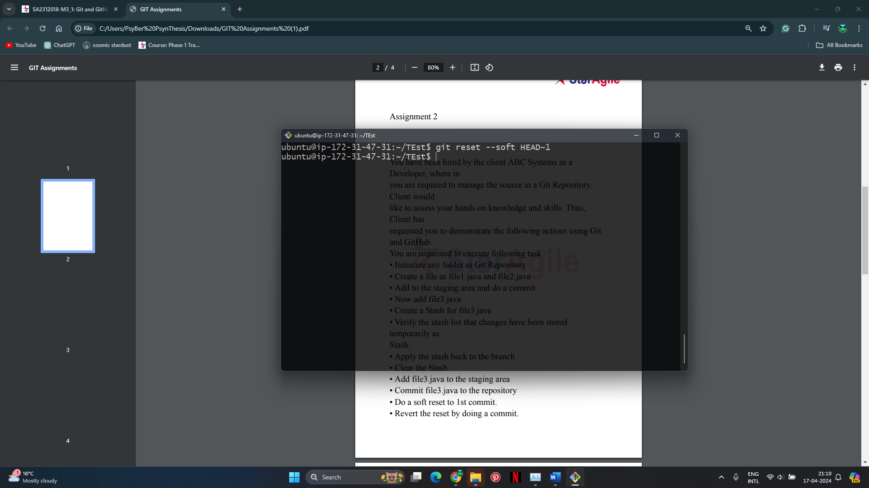

1. **Revert the reset by doing a commit:**
   * Run the commands: git commit -m "Revert reset"

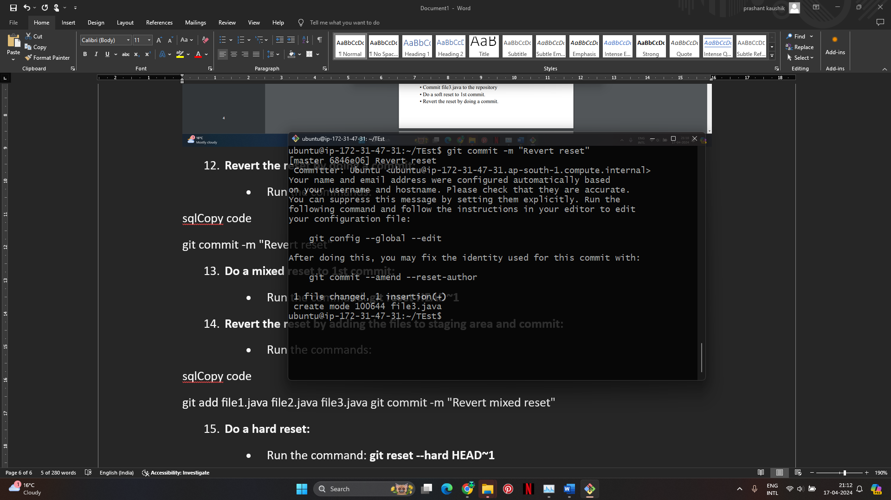

1. **Do a mixed reset to 1st commit:**
   * Run the command: **git reset HEAD~1**

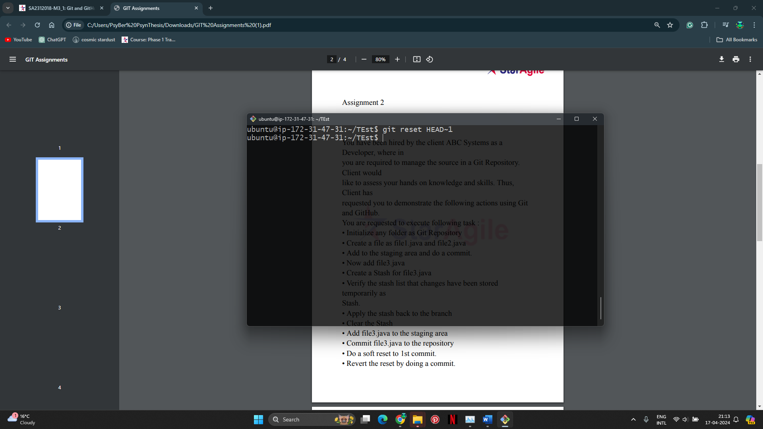

1. **Revert the reset by adding the files to staging area and commit:**
   * Run the commands: git add file1.java file2.java file3.java

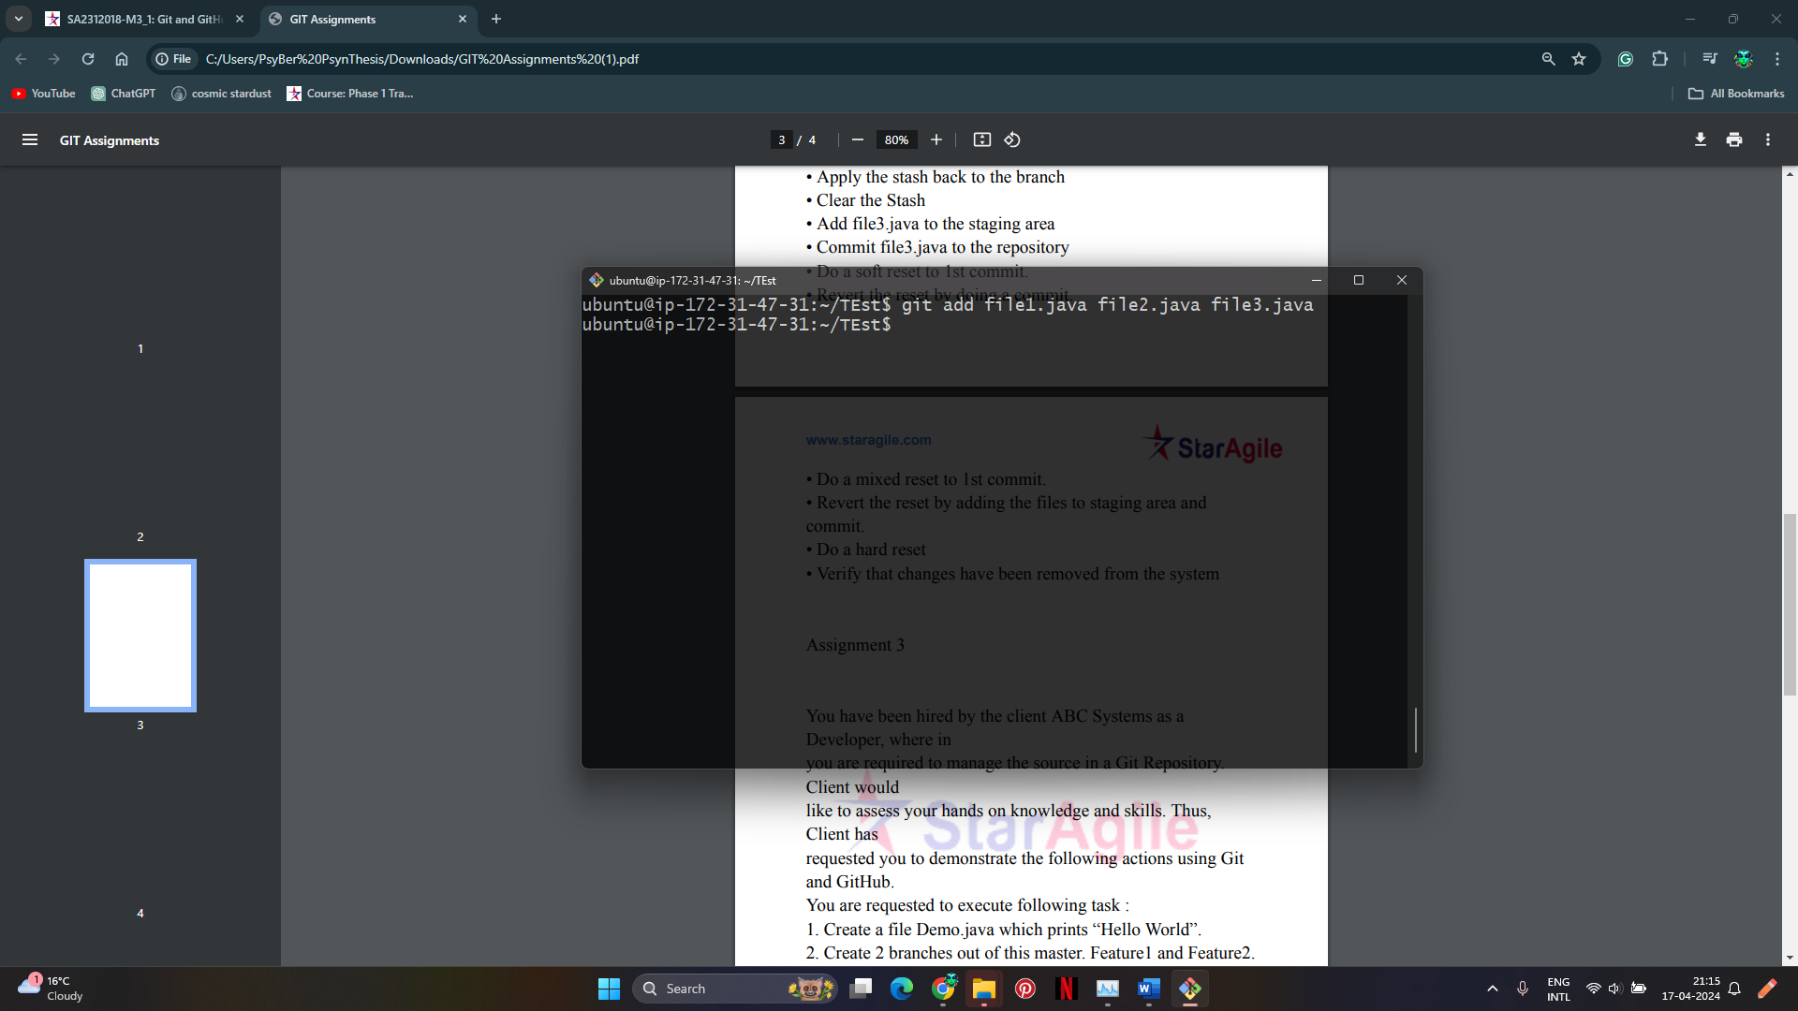

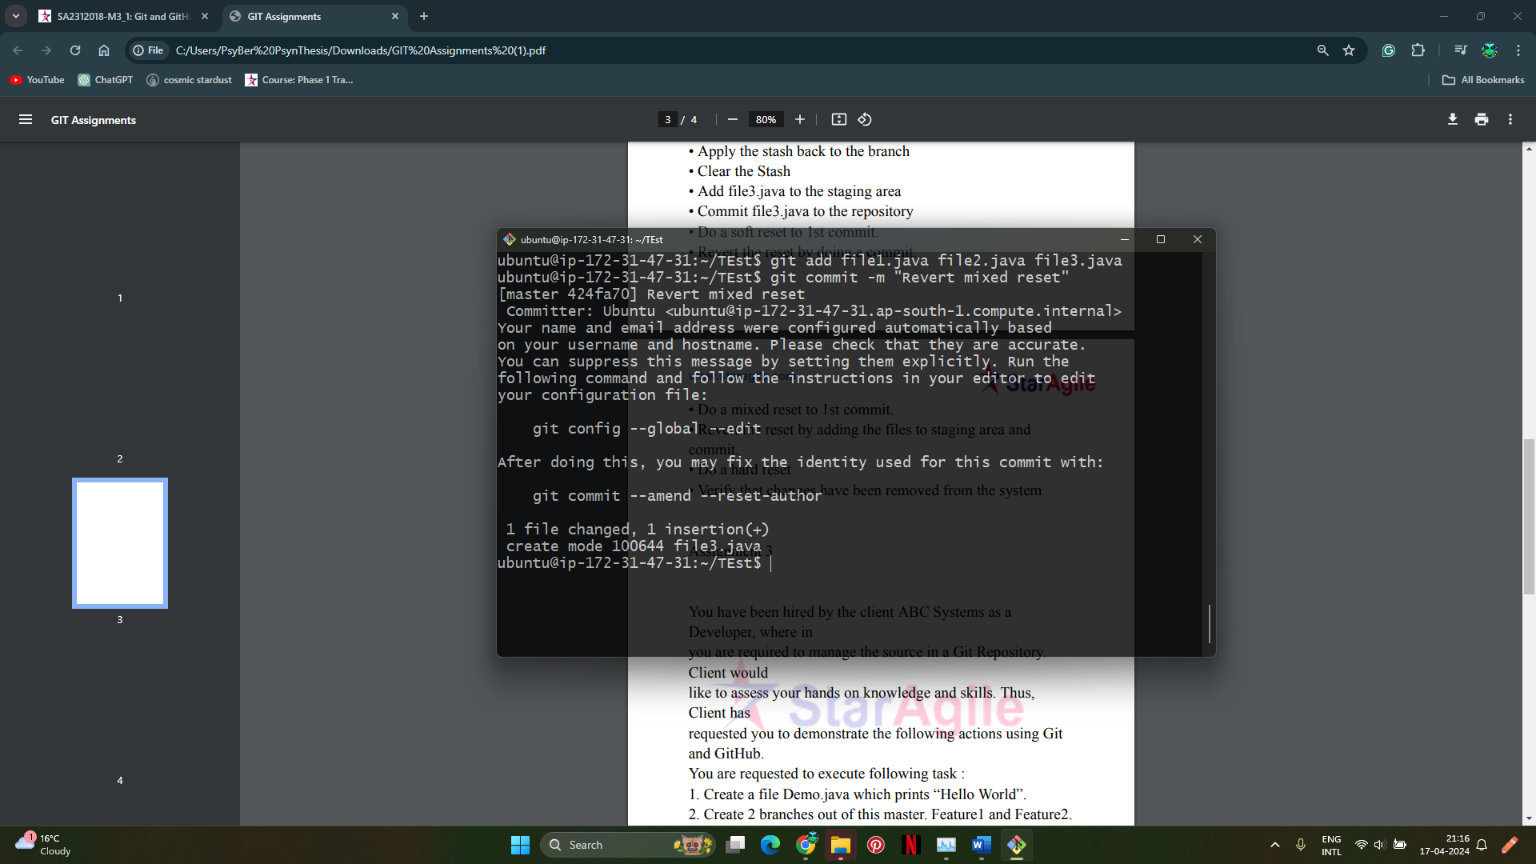

1. **Do a hard reset:**
   * Run the command: **git reset --hard HEAD~1**

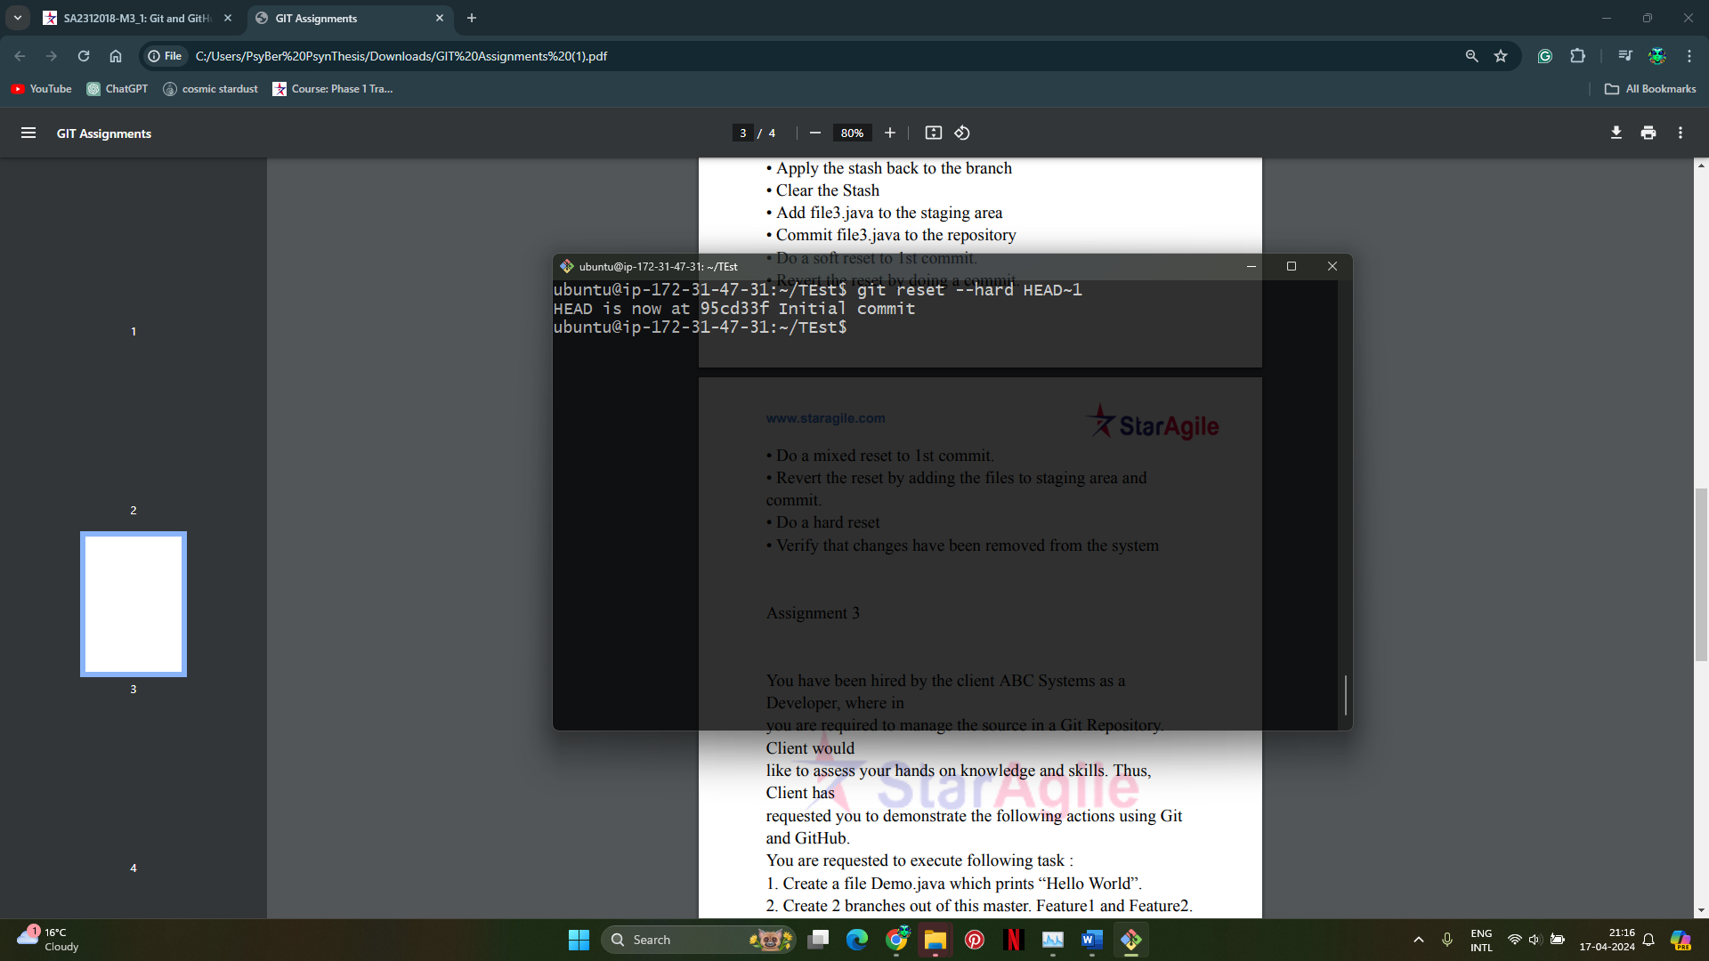

1. **Verify that changes have been removed from the system:**

